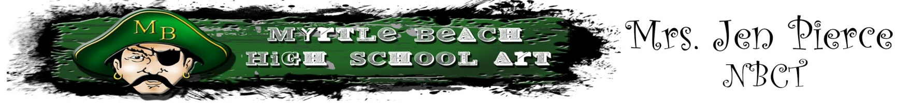

Day of the Dead: Sugar Skulls
Focus on Symmetry

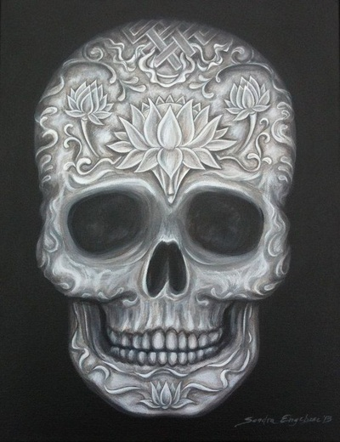

Grade Level: 9-12
Content Area: Art 1
Time to Complete: 2.5 90 minute class periods

Task Description: The student will be introduced to the Mexican celebration of the Day of the Dead. I like to do this lesson right before November 2nd. He/she will learn about symmetry, line variation, pattern, and value. This lesson is following a focus on shading so in this lesson the student is challenged to work from light to dark. This lesson also has a focus on the following elements and principles of design: Line, Value, Shape, Contrast, Pattern, BALANCE (symmetry), and Emphasis.

South Carolina Visual Arts Curriculum Standard Targeted: Grades 9-12
Goals:
I. Creative Expression-Students will develop and expand visual arts knowledge of media, techniques, and processes in order to communicate and express ideas creatively.
II. Aesthetic Perception/Creative Expression-Students will demonstrate knowledge of the elements and principles of design and aesthetic awareness of visual and tactile qualities of art objects and the environment.
III. Creative Expression/Aesthetic Valuing-Students will communicate ideas through selection of subject matter, symbols, and ideas in creating original artwork and evaluation of various artworks.
IV. Visual Arts Heritage-Students will demonstrate knowledge of artists, art history, world cultures and understand how the visual arts reflect, record, and shape cultures.
V. Aesthetic Valuing/Visual Arts Heritage-Students will make information responses regarding their work and the works of others through analysis, interpretation, and judgment.
VI. Visual Arts Heritage/Integration-Students will demonstrate knowledge of connections among the content of visual arts, other disciplines, and everyday life.
I. Understanding and applying media, techniques, and processes:
Students will
A. Communicate ideas through effective choice of media, techniques, and processes.
B. Apply media, techniques, and processes with sufficient skill, confidence, and sensitivity that their intentions can be observed in their artworks.
C. Demonstrate skillful and safe application with a variety of media, tools and equipment.
II. Using knowledge of structures and functions such as elements and principles of design:
Students will
A. Identify and describe the interrelationships among the elements and principles of design that communicate a variety of artistic perspectives and purposes.
B. Create artworks that use appropriate structures and functions to solve specific visual arts problems.
C. Evaluate the effectiveness of artworks in terms of organizational structure and function.
III. Choosing and evaluating a range of subject matter, symbols, and ideas:
Students will
A. Produce artwork that demonstrates personal choices and or interpretations about symbols, subject matter, ideas, and expression.
V. Reflecting upon and assessing the merits of their work and the work of others:
Students will
B. Make complex, descriptive, interpretive, and evaluative judgments about their artworks and the artworks of others.

Instructional Objectives:
1. The student will demonstrate careful and safe use of all tools and materials while creating a Sugar Skull
Assessment: Rubric & Teacher observation

2. The student will conduct research on the Mexican celebration of the day of the dead and record that on their inspiration blog within their digital portfolio.
Assessment: Digital Portfolio check

3. The students will create a Sugar Skull that has pattern and symmetry.
Assessment: Rubric, Teacher Observation, Self-evaluation

4. The student will participate in a peer critique.
Assessment: Teacher Observation, Peer Critique worksheet

Materials, Tools, and Equipment:
Black paper (12x18), white colored pencils, internet for references

Visuals & Resources:
On my website (www.MBHSart.weebly.com)

Vocabulary:
- Elements of Design (line, shape, form, color, value, texture, space)
- Principles of Design (balance, rhythm, movement, contrast, emphasis, pattern, unity)
- Symmetry
- Sugar Skull/Day of the Dead

Background Instructional Context:
Prior to this lesson the students have worked on portraits and shading with pencils.

Procedure: This lesson will take 2.5-90 minute class periods.

Directions: Start by showing them what the outcome will be. Introduce the celebration in Mexico called The Day of the Dead. I have a short 3 minute video from www.Youtube.com on my website. Discuss the ideas of symmetry and ask them for examples of symmetrical things. The teacher should demo how to start the sugar skull and how to approach shading from light to dark on the black paper.
Day 1: Intro to Day of the Dead and sugar skulls. The student will research and find examples that they want to pull inspiration from. The student should get the layout of their skull down and be adding patterns by the end of class.
Day 2: The student should continue working on adding patterns and details to their artwork focusing on keeping it symmetrical.
Day3: The student should go back in and clean up any stray marks. They can go back in today with a blending stump and blend out some of the white to create more values. My students have on online digital portfolio so before they turn this in they need to post it to their website and add a credit line and artist statement.

Assessment: The teacher will use a criterion referenced art production rubric to assess student achievement and by observation of class participation. Comprehension and application of the aesthetic values of shoes will be assessed through the peer critique.

Criteria

- Be an active learner by participating in peer critiques. Have an opinion!
- Draw on black paper
3. Fill the page (Have your skull centered)
4. Focus on keeping your drawing symmetrical (The exact same on both sides)
5. Have a nice range of values throughout your skull.
6. Fill the ENTIRE skull with interesting patterns and shapes.
7. Save some images for reference on your inspiration blog on your digital portfolio.
8. The skull should be drawn looking straight ahead (Don't draw a side view)

