Four Step Art Critique: Portrait Photography

Step 1 Description - What do you see?

Much like the information found on the credit line, a description has basic information about the artwork that you need to begin looking for.

- 1st You must identify the credit line information. (Title, Artist, Date created, medium)

- 2nd Describe what you see in the art work (trees, people, shapes, colors lines etc...)

My example:

Credit Line: “Migrant Mother”, Dorthea Lange, 1936, Photo)

Description: I see a woman with 3 children. 2 young kids seem to be standing up, but leaning against her for support. In her lap there is what appears to be a baby sleeping. The woman is staring blankly off into the distance. etc...

Photo credit: http://www.pbs.org/kenburns/dustbowl/bios/dorothea-lange/

Step 2 Analysis – How is the work organized?

Focus on how the elements and principles have been used to organize the work. This is a clue-collecting step, no guesses. Study in detail, how the elements and principles were used. How have the principles organized the elements? Cite specific examples from the artwork. Analyze how the elements are put together. This step helps you discover how the artist created any moods, messages or ideas in the work.

1. Use the vocabulary of art to analyze the artwork. Start by identifying which elements and principles you can clearly see in the work.
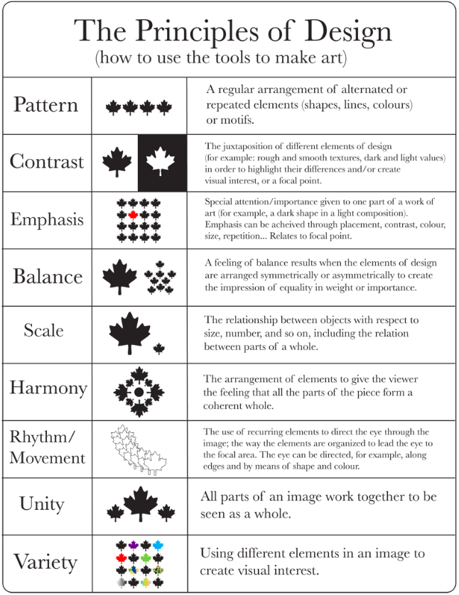
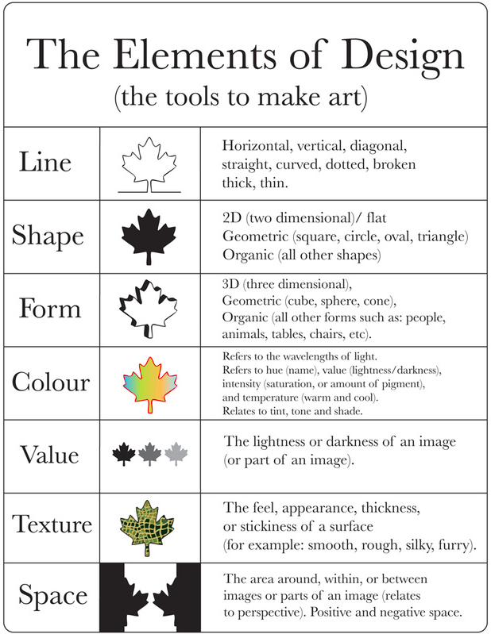
2. Now complete a paragraph using at least 5 elements & or principles of design.
Example:

There is a beautiful range of values in this photograph. The darkest area being her hair and around her face. The lightest are seems to be where the baby in her lap is.

Step 3 Interpretation – What is the artist saying?

Using the information you gathered in steps 1 and 2, explain what your discoveries tell you the artwork or artist is trying to communicate. What is the meaning or mood being told through the artwork? Make guesses about the meaning of the artwork. Use expressive descriptive language, e.g. softly, bold, bright, etc….

Questions to think about during this process:
- What do you think the artwork is about?
- Why do you think that?
- How does the artwork make you feel? Remind you of?

Example:
I think that the artist is trying to convey a message about the a mother’s desperation to care and provide for her children. The choice of where the values where places was a context clue for me. The darkness around her face reads as despair and the lightness around the baby feels like innocence and hope. Etc….

Step 4 Judgment – Is this a successful piece of art?

Now you can actually express your opinion about the success of the work. Your opinion is based however on what you discovered in the description, analysis and interpretation. You must be able to back up your opinion using the language of art. This is a carefully thought out decision in which you make a personal decision about an artwork's success or lack of success (NOT like or dislike), preparing reasons to support your judgment.

Is the work successful? Based on the different Theories Of Art. See other handout. o Imitation
Identify which criteria you are using for judgment
Cite Evidence (give reasons)
State you conclusions “I do not think this work is well designed because.....” or “I think
- this work is excellent because...”
Do the design qualities, elements and principles make the work successful or not?
Is the work well organized?
How does the realism or lack of realism affect the work?

Example:
I think this work is successful because it is wonderfully organized making it visually interesting. The mother in the middle-ground has a powerful presence that grabs the viewer’s attention. This picture reminds me of when I first found out I was going to be a mother. The idea of being responsible for another’s life is suffocating when you first think about it. Etc....

The outline for this 4 step critique came from: http://www.sbcusd.k12.ca.us/DocumentCenter/View/114320

