Intro to Color Theory
Color Scheme…Define…Create

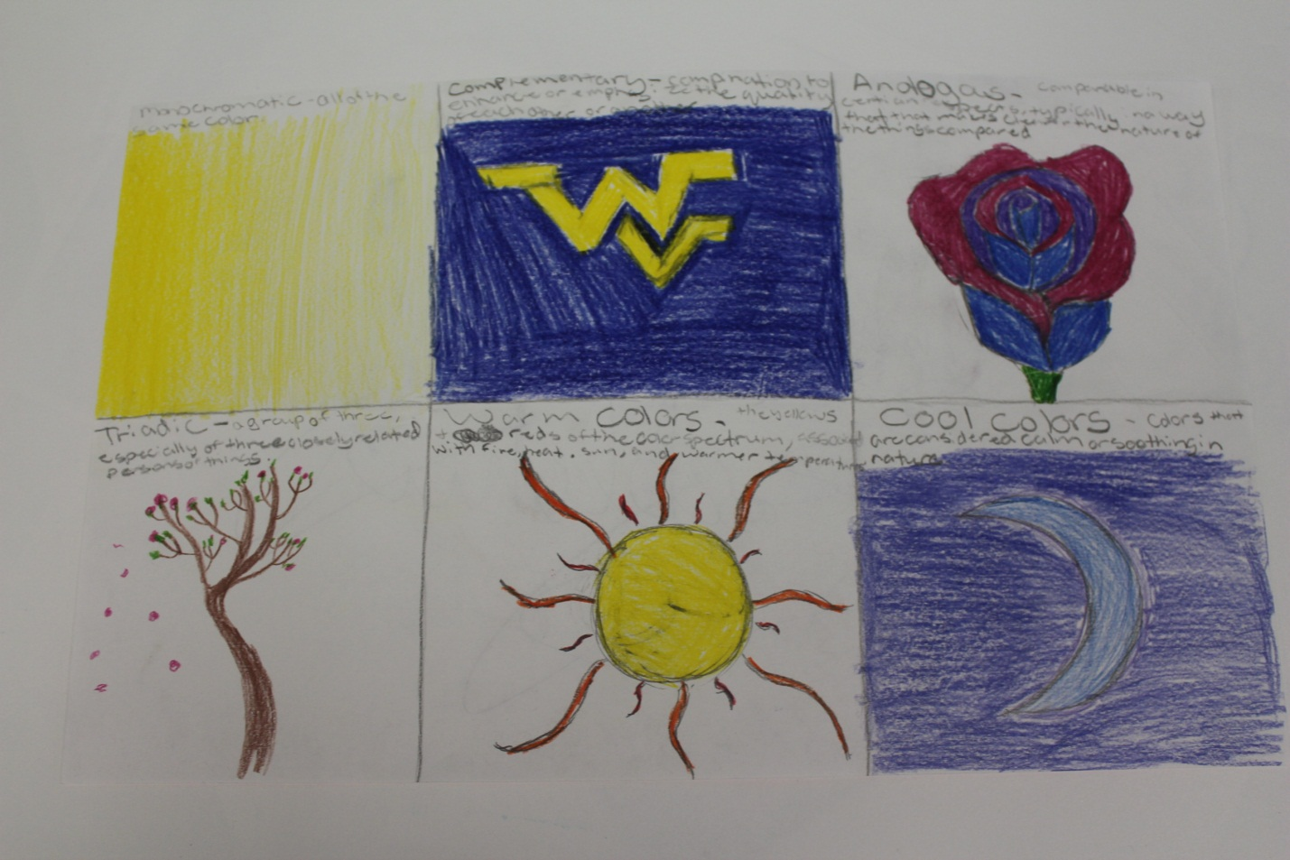

Grade Level: 9-12
Content Area: Art 1
Time to Complete: 1 90 minute class period

Task Description: The student will be introduced to 6 basic color schemes. He/she will learn how colors interact with one another. This lesson also has a focus on the following elements and principles of design: COLOR

South Carolina Visual Arts Curriculum Standard Targeted: Grades 9-12
Goals:
I. Creative Expression-Students will develop and expand visual arts knowledge of media, techniques, and processes in order to communicate and express ideas creatively.
II. Aesthetic Perception/Creative Expression-Students will demonstrate knowledge of the elements and principles of design and aesthetic awareness of visual and tactile qualities of art objects and the environment.

I. Understanding and applying media, techniques, and processes:
Students will
B. Apply media, techniques, and processes with sufficient skill, confidence, and sensitivity that their intentions can be observed in their artworks.
C. Demonstrate skillful and safe application with a variety of media, tools and equipment.
II. Using knowledge of structures and functions such as elements and principles of design:
Students will
A. Identify and describe the interrelationships among the elements and principles of design that communicate a variety of artistic perspectives and purposes.
B. Create artworks that use appropriate structures and functions to solve specific visual arts problems.

Instructional Objectives:
1. The student will demonstrate careful and safe use of all tools and materials while creating this project.
Assessment: Teacher observation

2. The student will create a color scheme reference sheet.
Assessment: Teacher Observation (Checklist)

Materials, Tools, and Equipment:
Sketch paper, colored pencils

Visuals & Resources:
Our class website: www.MBHSart.weebly.com

Vocabulary:
- Elements of Design : COLOR
- Monochromatic
- Analogous
- Complementary
- Triadic
- Cool Colors
- Warm Colors

Background Instructional Context:
Prior to this lesson the student has been learning basic drawing techniques. The student may not have any prior knowledge of color theory.

Procedure: This lesson will take 1 -90 minute class period.

Directions:
Start by going of the different color schemes and showing examples of them in various artworks. Have the student fold a piece of paper into 6 parts. In each box have the student write out a different color scheme and the definition. Then have the student draw a picture in each box. They must color each picture according to the color scheme of that box.

Assessment: The teacher will use a check list and observation of class participation to grade this assignment. This is a small intro project to color theory.

Criteria

-Get a blank sheet of paper from up front.
-Divide it into 6 parts either by folding it or using lines.
-Write the name of the color scheme and define it near the top of each box.
-Using colored pencils fill the box with an image using that color scheme.
The website Kuler.com is really great to help you explore and understand color relationships.
*Upload your work to your digital portfolio.

