Zombies: The Real Story of the Undead

From "World War Z" to "The Walking Dead" to "Shaun of the Dead" to "Pride and Prejudice and Zombies" and countless brain-dead rip-offs, zombies — reanimated corpses with an unstoppable craving for human flesh, especially brains — have invaded pop culture like never before. For staggering, slow-moving monsters, zombies have become quite a force in the entertainment industry over the past decade.

Zombies on the march in a scene from "Night of the Living Dead."
Credit: Public domain

Though George Romero's 1968 film "Night of the Living Dead" is often considered to be the original modern zombie film, the first actually appeared nearly 40 years earlier in "White Zombie," starring Béla Lugosi as an evil voodoo priest in Haiti who zombifies a beautiful young woman. In the years since, only a handful of zombie films have returned to their Haitian origins — most notably "The Serpent and the Rainbow."
According to the Oxford English Dictionary, the word "zombie" first appeared in English around 1810 when historian Robert Southey mentioned it in his book "History of Brazil." But this "Zombi" was not the familiar brain-eating manlike monstrosity but instead a West African deity. The word later came to suggest the vital, human force leaving the shell of a body, and ultimately a creature human in form but lacking the self-awareness, intelligence, and a soul. It was imported to Haiti and elsewhere from Africa through the slave trade.

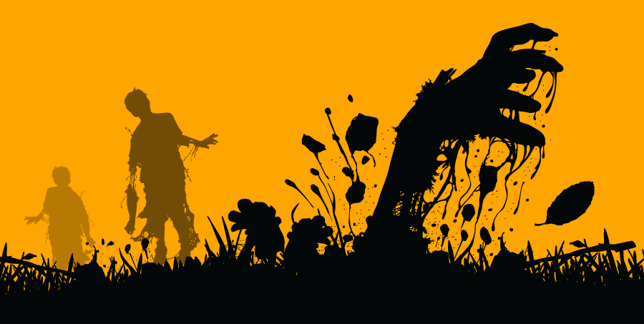

Stan Winston (April 7, 1946 – June 15, 2008)
Known primarily for his work on Spielberg's box office defining "Jurassic Park" (1993-2001) series' dinosaur designs and animatronics creations, Winston also wore the producer/director's hat on such modern monster horror classics as "Pumpkinhead" (1988) and others. For many decades, Winston was the leader of the pack when it came creative creature designs, making his name early in his career with other classics, "The Terminator" series (1984-2009), "Aliens" (1986) and "Predator" (1987). Stan Winston died after a seven year battle with multiple myeloma, leaving a huge blank spot in the special effects industry. It was a truly sad day for Horrorheads around the world when he passed on.

Bud Westmore (January 13, 1918 – June 24, 1973)
Bud Westmore came from a long line of special effects and makeup artists in old Hollywood, including such familial greats as George Westmore and Frank Westmore, and worked on some Universal's greatest monsters on the loose movies of the 40s, 50s and 60s, including his design for "The Creature From the Black Lagoon", an iconic monster from the studio responsible for "Dracula", "Frakenstein" and other iconic monster images in the genre. He worked with the great Jack Arnold on many of his giant radioactive monsters on the loose movies of the 50s, which would have been enough to include him on this list, but Bud Westmore's legacy was such a big deal for Universal that they named a studio in his honor on their backlot, something normally reserved for directors and producers important to the studio's legacy.

Tom Savini (Born: November 3, 1946)
This man is a legend in the genre, for his work in the 70s and 80s on such films, "Friday the 13th" (1980), "Dawn of the Dead", (1978) and "Maniac" (1980), just to name only a few, for his credits are many and varied. For decades, if there was an impossible gore effect to filmed, Tom Savini was the man to which they all came to make it happen. He has also appeared in several classic and modern classic horror titles such as George R. Romero's "Martin" (1977) and Quentin Tarantino's "From Dusk till Dawn" (1996). But he's also worn other hats in the industry, directing a surprisingly awesome remake of Romero's "Night of the Living Dead" (1990), and producing others. These days he also lends his name to a makeup/special effects school, where under his direct leadership and guidance, the young, new talents in the field are being molded every day. I could easily spend pages talking about this man's enormous influence on the horror industry, and not only in film, but in horror fiction as well. Without him, it is certain the 80s Splatterpunk movement would not have been as tremendously impactful as it was on the horror industry in all media formats, including today's video game entertainment industry. If you see his name in the credits of even the worst 80s horror movie made, watch it anyway, for you're sure to see something extraordinary in its special effects.

Lon Chaney, Sr. (April 1, 1883 – August 26, 1930)
Known as "The Man of a Thousand Faces" by his legions of adoring fans around the world, Chaney made special effects makeup what it is today. Without him, there's no way the industry would be as exciting as it has been and can still be with the right people working on real world SPFX. But he was an actor as well, and so he was always his own best test subject when it came time to creating the facial appliances for his classic silent era films, "The Hunchback of Notre Dame" (1923), "The Monster" (1925), "The Unholy Three" (1925), "The Phantom of the Opera" (1925) and hundreds more movies starring him and his makeup effects. Born to deaf and mute parents, Chaney learned to communicate with them by using body language and facial expressions that were out of the norm. He later applied these same tricks in his acting career to create some of the most iconic faces in the history of cinema. He was the world's favorite monster and his films weren't just releases, they were huge multimedia events, covered the world over. Sadly, when sound came along, his genius was diminished by the fact that now he also had to learn how to use his voice in his acting. It did not translate as well with movie going audiences and he finally fell from grace. But he passed along the acting bug to his son, Lon Chaney Jr., who would later become known for his own legendary portrayal of Universal's big budget special effects monster movie, "The Wolfman" (1941). This is a man who is more than legend; he is the foundation of the industry.

Gregory Nicotero (Born: March 15, 1963)
Oscar winning special effects master Greg Nicotero may have moved onto the realms of CGI effects in today's cinema in films such as the big budget adaptation of C.S. Lewis's "The Chronicles of Narnia: The Lion, the Witch and the Wardrobe" (2005), but it's his works for Romero's Undead series that we Horror-heads will always love him for best. He began his special effects career under the guidance of the master himself, Tom Savini (see #10 on this list). His later work on "Day of the Dead" (1985) is beyond horrifying, it's downright impossible looking, realistic as you can get, and mind blowing. It's also genre expanding, working along those thin lines of what is art and what is pure exploitative for the sake of shocking the viewer. And while any Horror-head worth his salt knows it's wonderful that one of our own has made it BIGTIME HOLLYWOOD in the above mentioned Narnia series of films, it's also great to see Nicotero has come back to us with his recent SPFX work on the incredibly intense and realistic zombie apocalypse AMC series "The Walking Dead" (2010-present), based on Robert Kirkman's graphic novel series of the same name. I expect he's due for even more awards in the coming months with this new project under his control. He knows how to make the undead seem to come to...well..life. Or is that unlife?

