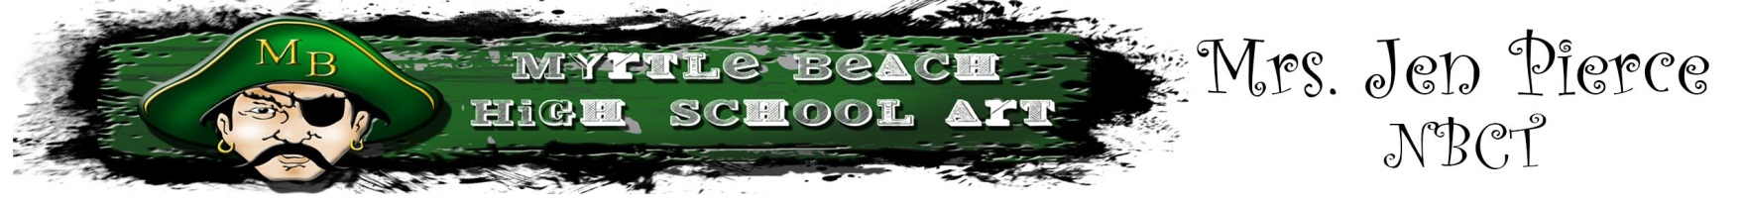

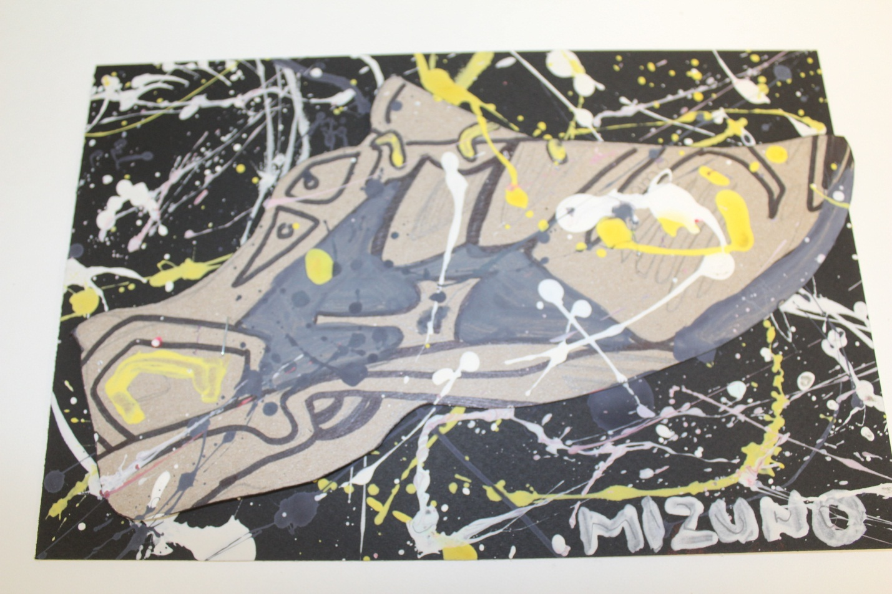
Dave White: Observational Shoe Drawing
From Drawing to Splatter Paint

Grade Level: 9-12
Content Area: Art 1
Time to Complete: 2.5 90 minute class periods

Task Description: The student will be introduced to observational drawing techniques. He/she will learn about searching lines, line variation, and breaking down harder objects into simple shapes. This lesson also has a focus on the following elements and principles of design: shape, line, color, balance and emphasis.

South Carolina Visual Arts Curriculum Standard Targeted: Grades 9-12
Goals:
I. Creative Expression-Students will develop and expand visual arts knowledge of media, techniques, and processes in order to communicate and express ideas creatively.
II. Aesthetic Perception/Creative Expression-Students will demonstrate knowledge of the elements and principles of design and aesthetic awareness of visual and tactile qualities of art objects and the environment.
III. Creative Expression/Aesthetic Valuing-Students will communicate ideas through selection of subject matter, symbols, and ideas in creating original artwork and evaluation of various artworks.
IV. Visual Arts Heritage-Students will demonstrate knowledge of artists, art history, world cultures and understand how the visual arts reflect, record, and shape cultures.
V. Aesthetic Valuing/Visual Arts Heritage-Students will make information responses regarding their work and the works of others through analysis, interpretation, and judgment.
VI. Visual Arts Heritage/Integration-Students will demonstrate knowledge of connections among the content of visual arts, other disciplines, and everyday life.
I. Understanding and applying media, techniques, and processes:
Students will
A. Communicate ideas through effective choice of media, techniques, and processes.
B. Apply media, techniques, and processes with sufficient skill, confidence, and sensitivity that their intentions can be observed in their artworks.
C. Demonstrate skillful and safe application with a variety of media, tools and equipment.
II. Using knowledge of structures and functions such as elements and principles of design:
Students will
A. Identify and describe the interrelationships among the elements and principles of design that communicate a variety of artistic perspectives and purposes.
B. Create artworks that use appropriate structures and functions to solve specific visual arts problems.
C. Evaluate the effectiveness of artworks in terms of organizational structure and function.
III. Choosing and evaluating a range of subject matter, symbols, and ideas:
Students will
A. Produce artwork that demonstrates personal choices and or interpretations about symbols, subject matter, ideas, and expression.
V. Reflecting upon and assessing the merits of their work and the work of others:
Students will
B. Make complex, descriptive, interpretive, and evaluative judgments about their artworks and the artworks of others.

Instructional Objectives:
1. The student will demonstrate careful and safe use of all tools and materials while creating an cyanotype mural
Assessment: Rubric & Teacher observation

2. The student will create 4 preliminary sketches of 4 different angles of a shoe.
Assessment: Rubric, Teacher Observation (Checklist)

3. The students will create a Dave White inspired splatter paint shoe composition.
Assessment: Rubric, Teacher Observation, Self-evaluation

4. The student will participate in a peer critique.
Assessment: Teacher Observation, Rubric, Peer Critique worksheet

Materials, Tools, and Equipment:
Sketch paper, pencil, shoes, tempera paint, brushes, cardboard and mat board

Visuals & Resources:
Dave White: http://davewhiteart.com/

Vocabulary:
- Elements of Design (line, shape, form, color, value, texture, space)
- Principles of Design (balance, rhythm, movement, contrast, emphasis, pattern, unity)
- Splatter Painting/action painting
- Observational Drawing

Background Instructional Context:
Prior to this lesson the students have worked on right brain drawing activities such as upside down drawing and +/- space drawing.

Procedure: This lesson will take 2.5-90 minute class periods.

Directions: Start by showing them what the outcome will be. Introduce the art work of Dave White and discuss the impact his art has had in the advertising world. The student then needs to select a shoe that they would like to do a 4 angle observational shoe drawing of. The teacher should demo how to start an observational drawing (simplifying the object into shapes, and searching lines/gesture). Explain contour lines and varying line thickness. They should spend 1 full day on these. Day two they need to finish up their 4 angles within the first 30 minutes. They are to pick their favorite angle from their study to draw on a piece of cardboard. This drawing should be in pencil and then they can use some mixed media on it to help create an emphasis. Once that is complete they can do their splatter paint background. I created a space inside for this “event” to take place. I told them to use either black or white and no more than 3 more colors since we have not gone over color theory yet. As soon as they finish their background they need to staple their finished drawing to the background and then go back in and add some more splatters purposely on top. Most students will complete the splatter painting part on the 3rd day.

Assessment: The teacher will use a criterion referenced art production rubric to assess student achievement and by observation of class participation. Comprehension and application of the aesthetic values of shoes will be assessed through the peer critique.

Splatter Paint Shoe Rubric
Criteria | 0-Unsatisfactory | 1-Needs Improvement | 2- Satisfactory  (Target) | 3- Exceeds Expectations
Preliminary  Sketch | No sketches made. | Student makes a sketch that is not fully executed. Little attention to the elements & principles of design & to a theme. | Student has a complete sketch. Student uses the resources given. | Student has a well thought out sketch. Fully utilized all the elements & principles of design and has a clear, thought out theme.
Class Participation | Student does not participate and shows no interest. | Student used the materials handed to them, but not for the project at hand. | Student was focused on the task. | Student was engaged in class work and had insightful ideas.
Clean Up | Student does not clean up and their area is a mess. | Student only makes an effort to put a few things away. | Student fully cleans up their area. | Student not only cleans up their area, but volunteers to assist others.
Peer Critique worksheet and participation. | Did not do the worksheet and did not participate in the critique. | Less than half the worksheet was filled out and they contributed little to the critique. | Worksheet completed which helped to guide them during the critique discussion. | Was able to fully articulate the vocabulary learned in this lesson and express why a shoe was successful or not in an eloquent tongue. Sheet was carefully filled out, and the student was an asset to the critique, encouraging others to participate.
Oral Presentation/ Critique | Unwilling to participate. | Presented, but there was no preparation. | Presented well. Ideas were clear and precise. | Well rehearsed. Highlighted on what influenced them, their theme and clearly explained the thought process behind the elements and Principles of design used.
Safe and careful use of tools. | Neglected carefulness and misused tools. | Played around with tools in a way that was unrelated to the project at hand. | Correctly used tools and took the proper safety precautions at all times. | Not only watched out for themselves, but helped other to use their tools in a safe and careful manner.
Self evaluation sheet. | Did not try to fill out. | Filled out less than half. | Completed the sheet. | Was able to show his/her knowledge of vocabulary through his/her answers on the worksheet.

Criteria

- 4 observational drawings of a shoe from different angles.
- Final shoe study on cardboard with line variation and mixed media applied.
- Splatter paint background
- Use your body, opaque, translucent, and refracting materials.
- Use color, line, shape, balance, and emphasis
- Worksheets: peer critique, Self-evaluation.
- Be an active learner by participating in peer critiques. Have an opinion!

