Steve McCurry

The Afghan Girl
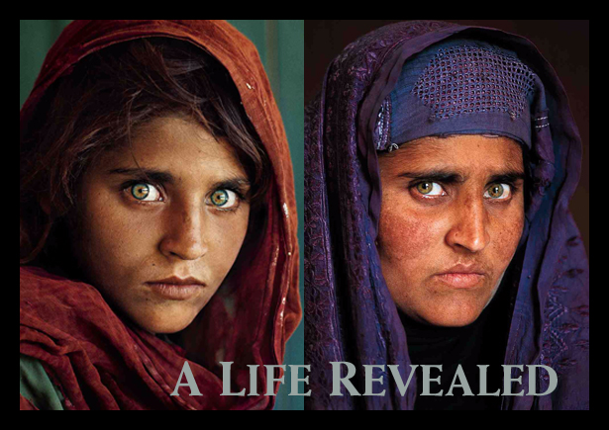

Sharbat Gula is an Afghan woman who was the subject of a famous photography journalist Steve McCurry. Gula was living as a refugee in Pakistan during the time of the Soviet occupation of Afghanistan when she was photographed. The image brought her recognition when it was featured on the cover of the June 1985 issue of National Geographic Magazine at a time when she was approximately 12 years old. Gula was known throughout the world simply as "the Afghan Girl" until she was formally identified in early 2002. The photograph has been likened to Leonardo da Vinci's painting of the Mona Lisa and is sometimes popularly referred to as "the Afghan Mona Lisa".
Although her name was not known, her picture, titled "Afghan Girl", appeared on the June 1985 cover of National Geographic. The image of her face, with a red scarf draped loosely over her head and with her piercing sea-green eyes staring directly into the camera, became a symbol both of the 1980s Afghan conflict and of the refugee situation worldwide. The image itself was named "the most recognized photograph" in the history of the magazine.

